SR UNIVERSITY
AI ASSIST CODING
Lab-4.4
2503A51L18
E.RAVALI
BATCH:19
TASK #1:
Prompt Used:
Write a class definition comment and start the constructor for a class called BankAccount with account_holder and balance attributes. Use GitHub Copilot to auto-complete the rest of the class, including methods to deposit, withdraw, and display balance.
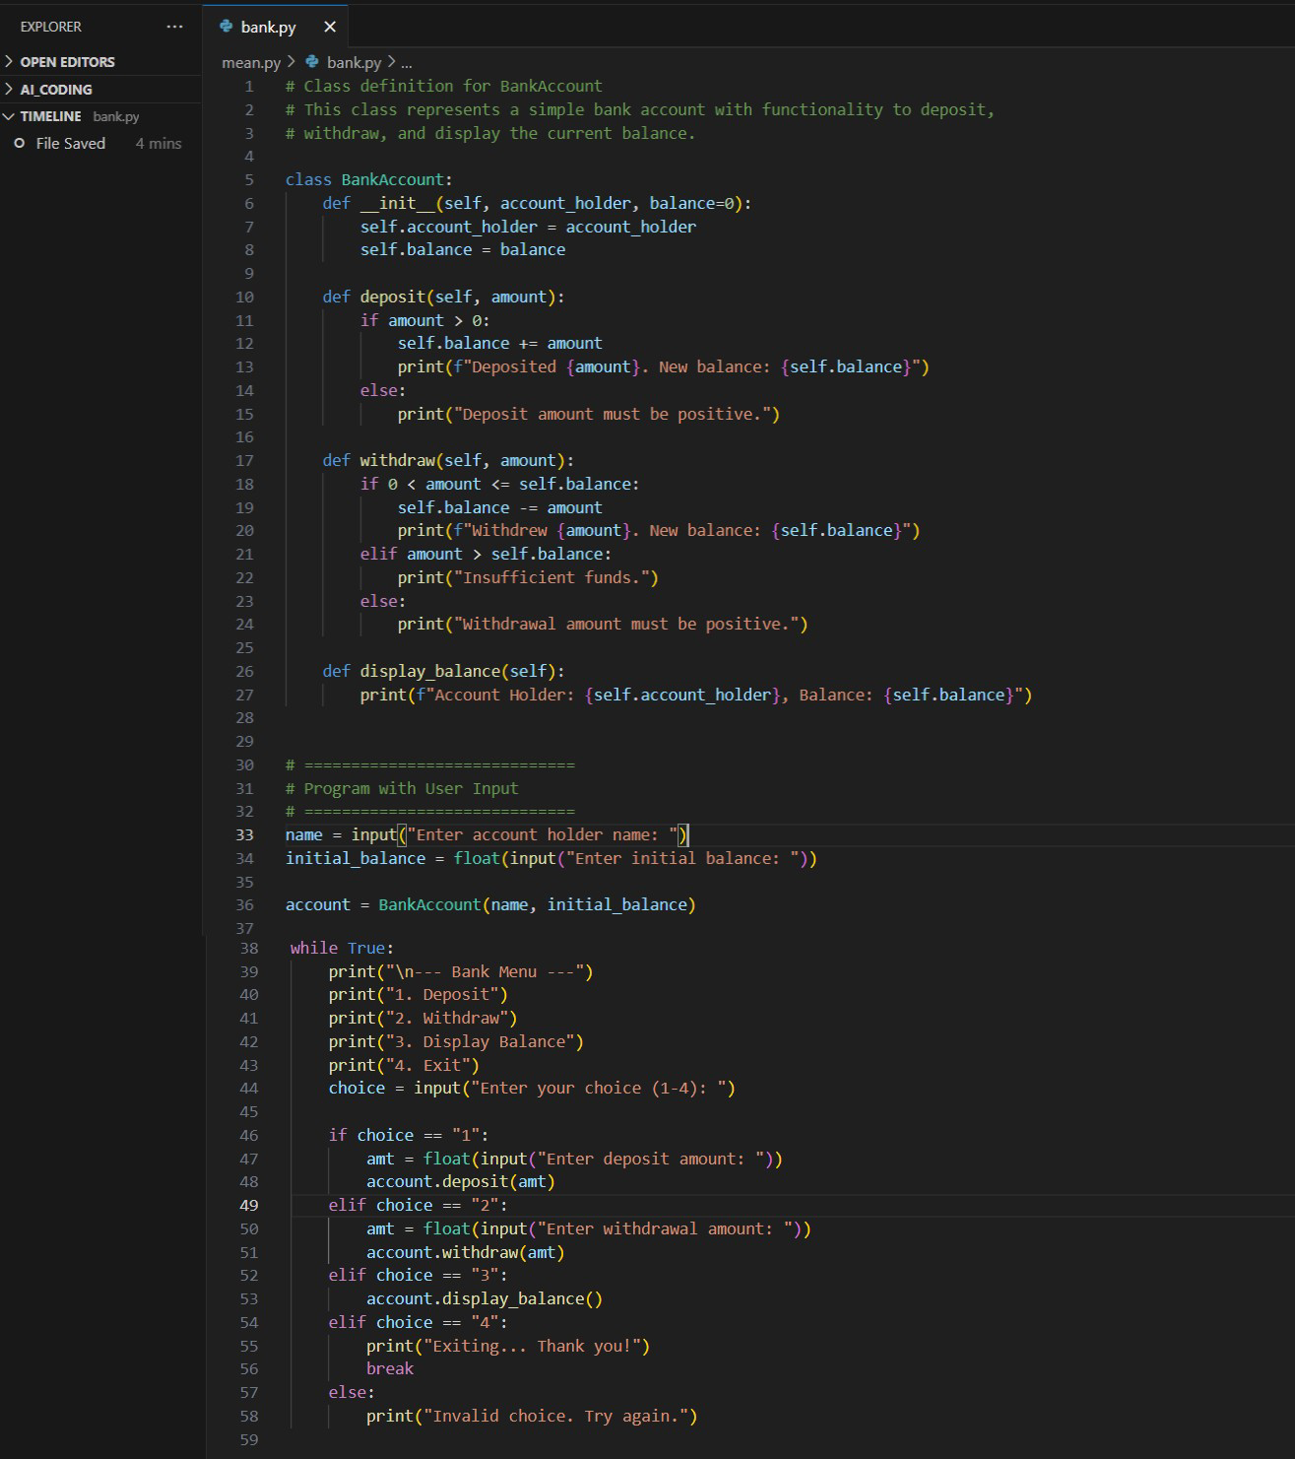
Code Generated:

Output After executing Code:
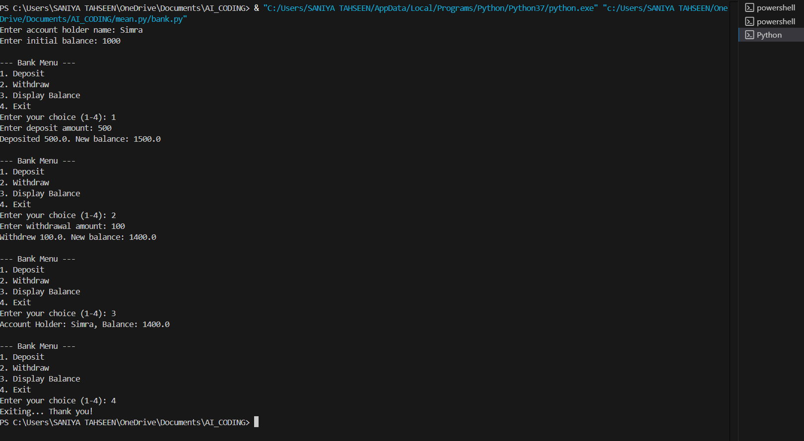
Observations:
- The BankAccount class is created with account_holder and balance attributes, initialized via the constructor.
- It includes methods to deposit, withdraw, and display balance, each with proper validation.
- A menu-driven loop allows users to perform transactions interactively using input options.

TASK #2:
Prompt Used:
Write a comment and the initial line of a loop to iterate over a list. Allow GitHub Copilot to complete the logic to sum all even numbers in the list.
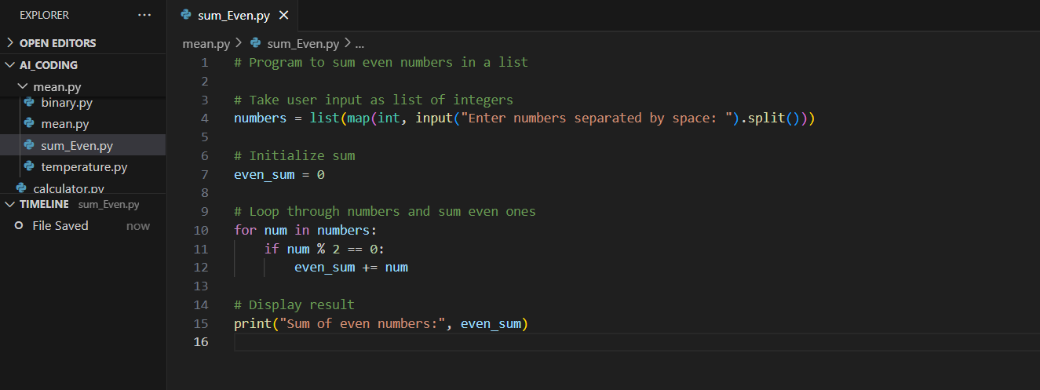
Code Generated:
Output After executing Code:
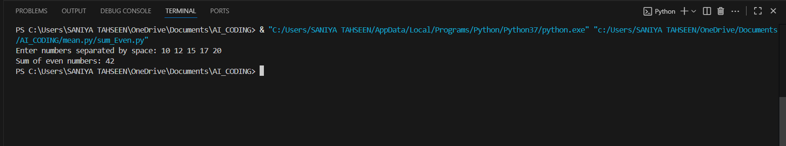
Observations:
- The program accepts a list of integers from the user using input().split() and converts them with map(int, ...).
- An accumulator variable (even_sum) is initialized to 0 to store the running total of even numbers.
- Each number is checked with the condition num % 2 == 0 to determine if it is even.

TASK #3:
Prompt Used:
Start a function that takes age as input and returns whether the person is a child, teenager,
adult, or senior using if-elif-else. Use Copilot to complete the conditionals.

Code Generated:
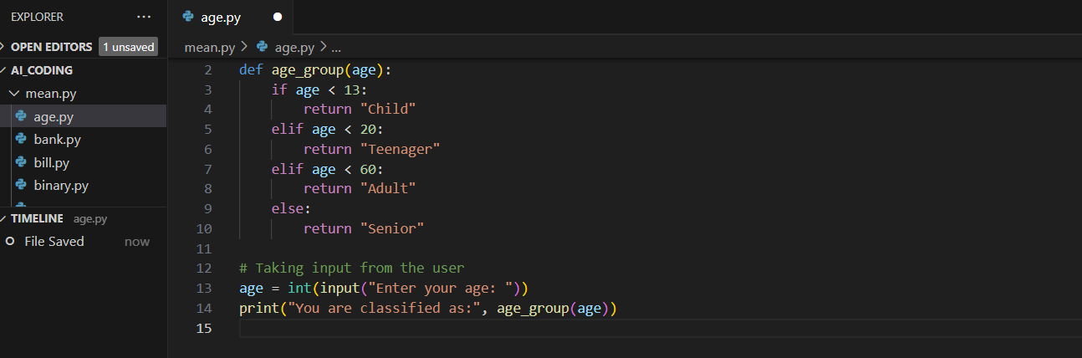
Output After executing Code:
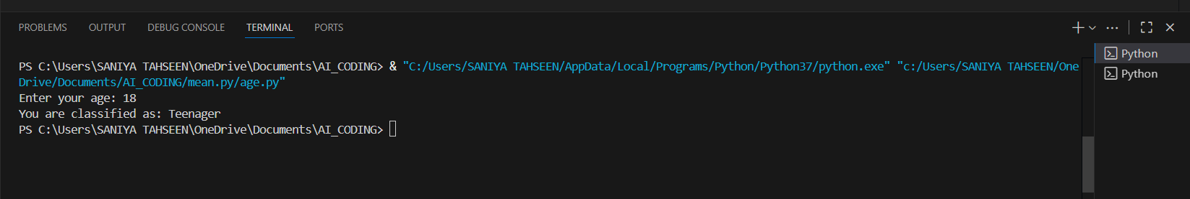
Observations:
- The function age_group(age) uses if–elif–else to categorize the given age.
- Age ranges are checked in order: <13 → Child, <20 → Teenager, <60 → Adult, else → Senior.
- The result is returned as a string.

TASK #4:
Prompt Used:
Write a comment and start a while loop to reverse the digits of a number. Let Copilot complete the loop logic
Code Generated:
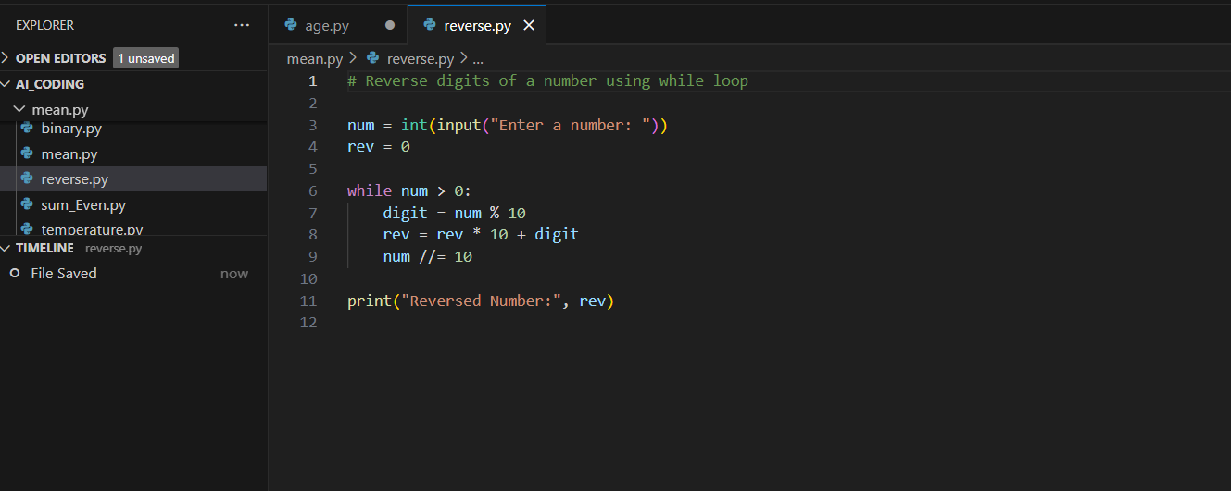
Output After executing Code:
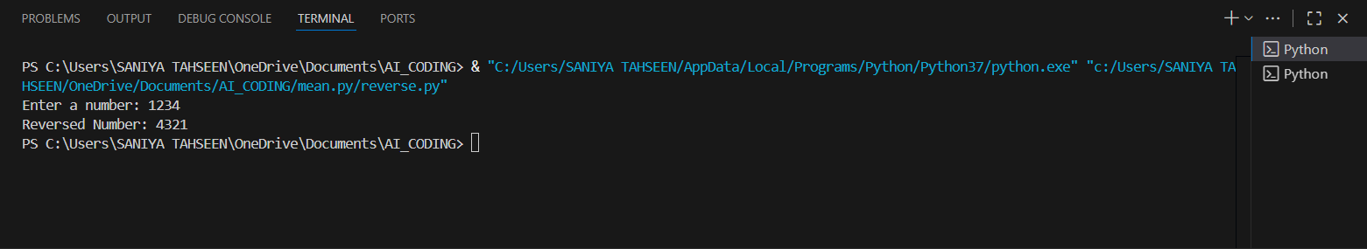
Observations:
- The last digit is obtained using num % 10 and added to the reversed number.
- The reversed number is built step by step using rev = rev * 10 + digit.
- After each step, the last digit is removed from the original number using num //= 10.

TASK #5:
Prompt Used:
Begin a class Employee with attributes name and salary. Then, start a derived class Manager that inherits from Employee and adds a department. Let GitHub Copilot complete the methods and constructor chaining.
Code Generated:
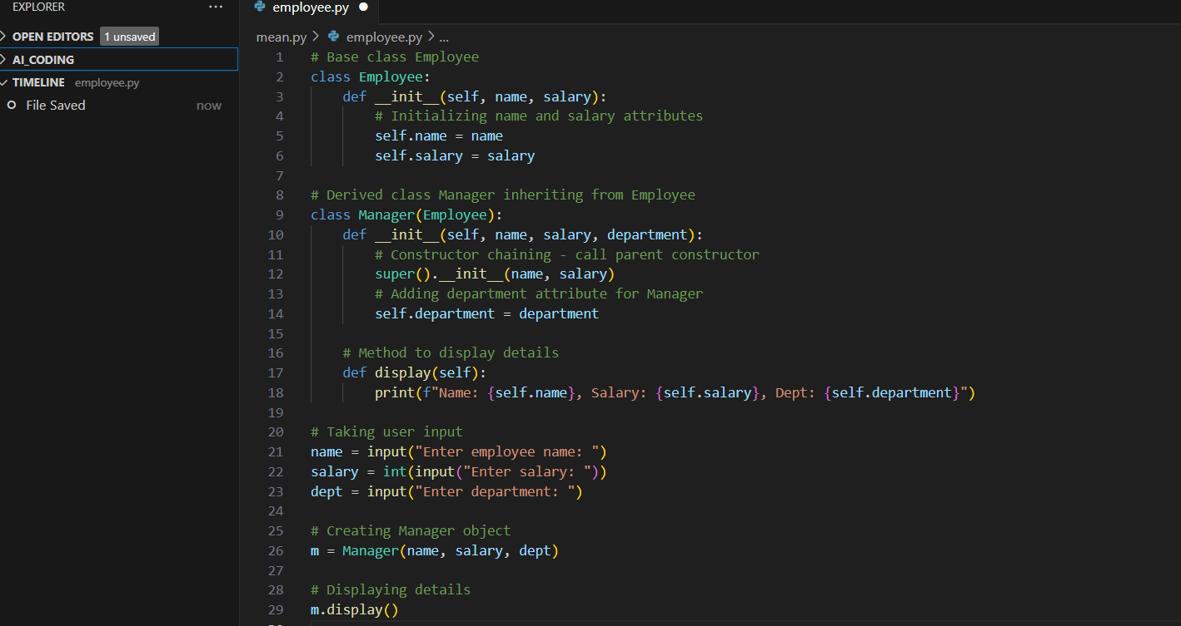

Output After executing Code:
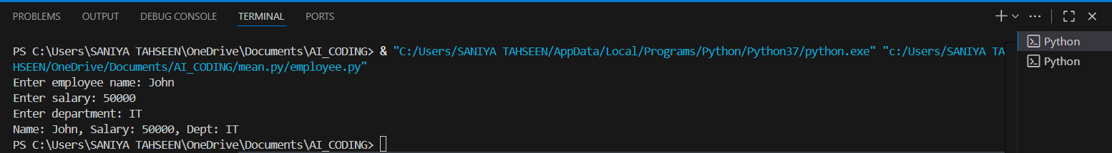
Observations:
- The Manager class inherits attributes from the Employee class and adds a new attribute department.
- Constructor chaining is achieved using super(), which allows reuse of the parent class constructor.
- Input is taken from the user to dynamically create an object with given values.

